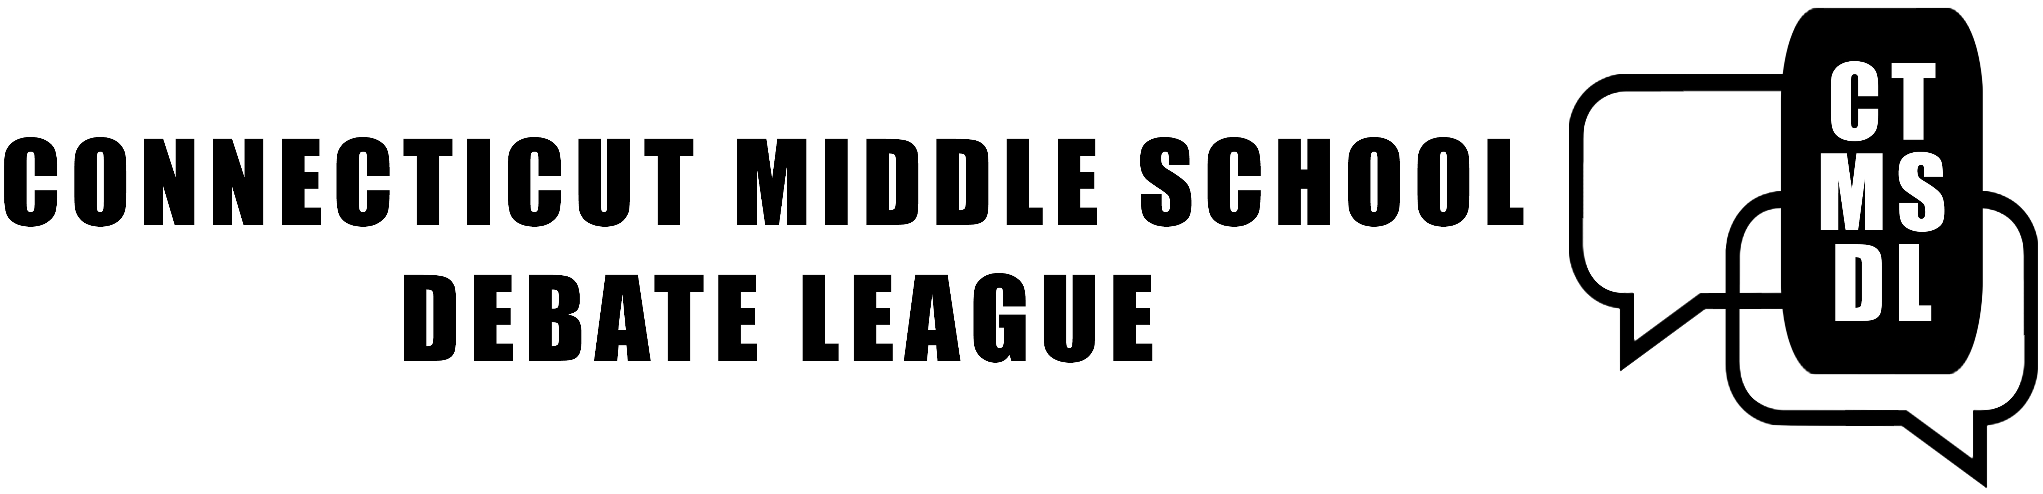
Tournament, Saturday, May 9, 2020, 8:30 am — 8:30 pm
ONLINE!
Sponsored by the English Speaking Union, Greenwich Branch

The Connecticut Middle School Debate League invites you to the third tournament of the season. Debaters who will compete should research the topic: This House believes that it’s time to expand nuclear power for civilian use.
Please refer to the updated CTMSDL Handbook for information on our format and rules. READ ABOUT NOVICE & OPEN CATEGORIES. Teams that have competed twice in the Novice category should consider registering in the Open category.
Coaches should register their debaters through tabroom.com. Download our tabroom.com Instructions for more information. On tabroom.com the event name is “ctmsdlmay9.” There is no cap on the number of teams each school may enter.
Coaches should register 1 judge per every 2 teams. Schools only bringing 1 team should register 1 judge. REGISTER EXPERIENCED JUDGES IN OPEN CATEGORY, NEWER JUDGES IN NOVICE CATEGORY.
Coaches should make sure their judges understand the information in the CTMSDL Handbook and our Judges’ Instructions.
Zoom Meeting ID & Password sent to coaches | 7:30 am
Judge Training | 8:30 am
Debaters Join Zoom Meeting | 9:30 am
Round 1 | 10:30 am
Round 2 | 1:30 pm
Round 3 | 4:30 pm
Final Round (top 2 Open level teams) | 7:30 pm

Questions or comments? Please email Jen Posner: jen.posner@ctmsdebate.org .

