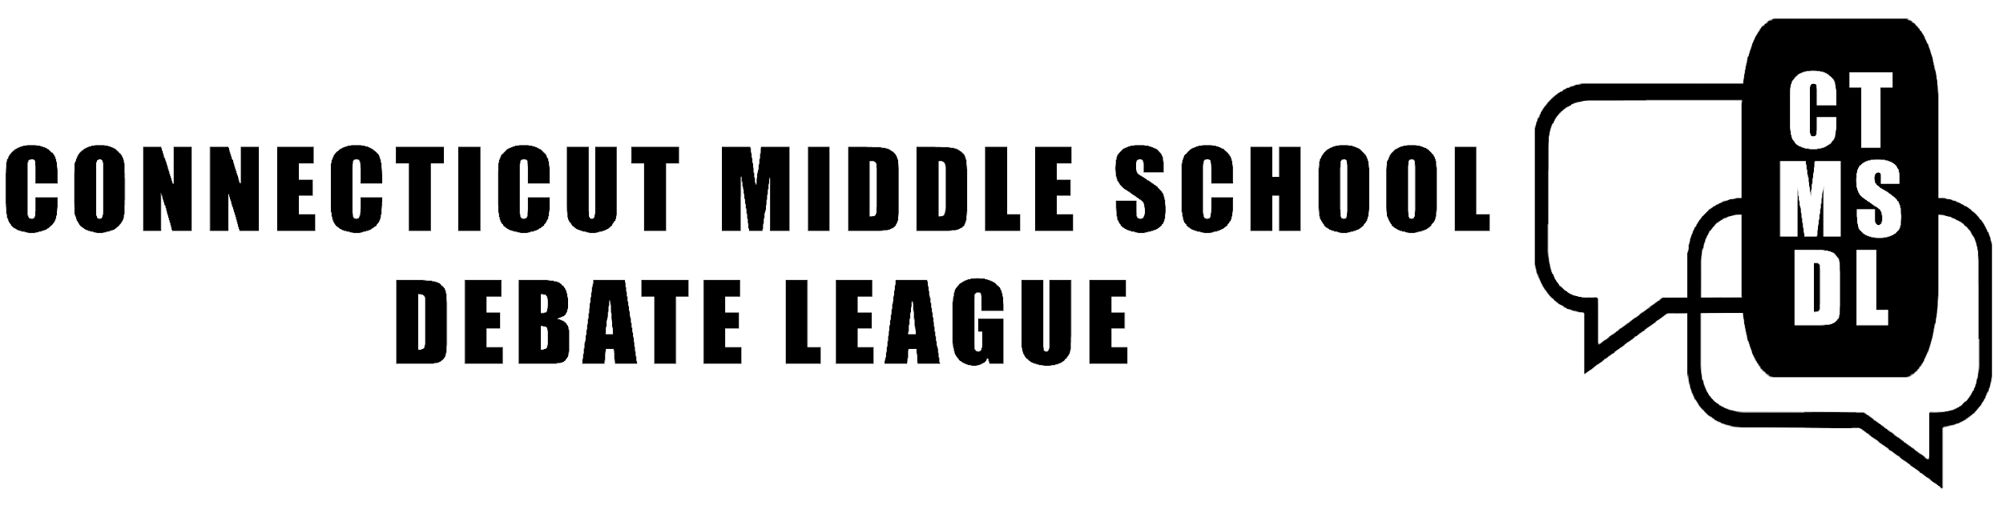

Minutes, June 16, 2020 Spring Coaches’ Meeting

1. Jen Posner and Bruce Johnson contributed to these minutes.

In Attendance:
Angelo Calebrese, Board Member, CTMSDL; Torrington Middle School, Torrington
Harvey Catlin, Seymour Middle School, Seymour
Katie Durkin, Middlebrook Middle School, Wilton
Lee-Ann Harris, Board Member CTMSDL; Ethel Walker School
Ann Walsh Henderson, Board Member CTMSDL; Westfield Academy, West Hartford
Jennifer Hunt, Board Member, CTMSDL; The Hive, Redding
Bruce Johnson, VP, CTMSDL; Eastern Middle School, Greenwich
Charlie McIntyre, Polson Middle School, Madison
Maia Pavlick, Cromwell Middle School, Cromwell
Michael Panoli, Board Member, CTMSDL; Middlebrook Middle School, Wilton
Jen Posner, President, CTMSDL; Westfield Academy, West Hartford
John Rook, Board Member, CTMSDL; Smith Middle School, Glastonbury
Everett Rutan, Executive Director, CDA
Steven St. Onge, Cromwell Middle School, Cromwell
Josephine Shea, Irving A Robbins Middle School, Farmington
Max Wu, Polson Middle School, Madison

2. Members approved the Spring 2019 minutes.

3. Membership & Participation (see Agenda).
- 5 new schools joined (AITE is several Stamford schools coached by AITE).
- 4 schools dropped (1 plans to try again next season).
- We had 29 schools participate; 24 paid dues (2 don’t need to pay).
- Jen will try to collect payment from 3 schools.
- We will try to recruit new schools this summer (Jen, Bruce, Jennifer Hunt will reach out to principals through Cherese at CAS, Maia and Steven St. Onge from Cromwell are willing to assist new teacher-coaches). We’ll invite interested schools to observe events this year.

4. Virtual Tournaments.
The April Zoom tournament went well although attendance was way down (see Agenda). Right now Zoom allows 50 Breakout Rooms for Meetings with < =200 participants and only 30 Breakout Rooms for Meetings of >200 participants. If this doesn’t change by October, we may have to run 2 tournaments, 1 Novice and 1 Open. It depends on how many schools participate.

5. 2020-21 Schedule & Hosts
For now we are assuming all events will be virtual. We will reassess if things change. Our goal is to give coaches more time to recruit debaters at the beginning of the year and to meet with their teams between events, as we are assuming Debate Team meetings will be virtual too.

Scrimmage: Saturday, October 24, 2020
Tournament: Saturday, December 19, 2020
Tournament: Saturday, February 27, 2021
Tournament: Saturday, April 24, 2021
Championship Tournament: Saturday, May 22, 2021

6. Budget
We passed the budget (see Agenda) with the addition of postage to mail awards. Dues will remain $50/year. As always, new schools may attend one event before paying dues.

Why does the CTMSDL have a surplus of around $3000? When we started, we didn’t know if the ESU would continue to fund us every year and we assumed we’d have miscellaneous expenses (for example we bought a Tab computer last summer).

Doing events virtually gives us the opportunity to include schools that can’t afford to travel. We agreed we will try to recruit new schools, possibly using our surplus to address technology issues.

7. Governance.
All current Board members will continue. Steven St. Onge from Cromwell and Harvey Catlin from Seymour will join.

8. MSPDP 2020 Championship Tournament
CTMSDL was invited to send 4 teams to a virtual Middle School Public Debate Program (MSPDP) championship tournament in May. The top ranking teams from December and January from schools that permitted kids to do online events competed (Westfield, Irving A Robbins and The Hive). A good time was had by all.

9. Novice & Open Categories.
Coaches generally thought the divisions worked well.

We will mail physical trophies and email certificates the top 3 Open Level speakers and teams. Novice Level teams that go 3-0 will be sent gavel pins and emailed certificates. Novice certificates will say, Congrats! You May be Ready to Move Up to Open Level! However, the decision as to which category (Novice or Open) to enter debaters into will still be up to Coaches. Our Handbook will stay the same: Beginning with the 2019-20 season, CTMSDL events will have two divisions for Scrimmages and Tournaments: Novice & Open. The Novice division is for brand new debaters. Coaches will have discretion regarding which category to place debaters in. Debaters must compete in the same division as Speakers and as Team members. Coaches are encouraged to move Novice teams that go 3-0 (3 wins, no losses) at any tournament to the Open Division. We won’t publish ranks for the Novice division. The only awards for novices will be gavel pins for Teams that go 3-0.

10. Championship Tournament.
Coaches decided to plan for our first Championship Tournament. (This year’s was cancelled because too many schools couldn’t join us virtually.) The following are ways debaters can qualify:
1. top 10 Open Level speakers at any of the 3 tournaments
2. member of an Open Level team that placed in the top 10 at any of the 3 tournaments
3. member of an Open Level team that went 3-0 at any of the 3 tournaments
The Handbook will be updated to reflect this change.

11. Procedures.
We will continue to release the October Scrimmage topic in August and offer coaches Prop and Opp briefs that help the coaches get up to speed on the topic and possible frameworks and arguments. It’s up to coaches to decide whether or not to share the briefs with debaters.

Motions will be released at the end of the scrimmage and tournaments this season. The October topic will be election-related.

Videos. Our goal this summer is to produce instructional videos that will help new debaters, coaches, and judges.

12. Professional Development.
We’ll meet by Zoom on Monday, August 3 from 8:30 am to 12:30 pm. We’ll bring in some college debaters to discuss Rebuttal Speeches, Flowing and more! PUT IT IN YOUR CALENDARS & DON’T MISS IT

